Project Proposal

Project subject: WeatherMapRoute

Project team members: Yasser Soofiyani and Thanh-Tung Pham

Trello: <https://trello.com/b/RUjD1FK9/project>

Git: <https://github.com/tpham20908/WeatherMapRoute>

Description:

Our Project is about travel shearing or tour management.

For example, someone for travel shearing or find a follow traveler or any reason can create a rout with some stop spot and other people can find this rout map and join together.

Also our application has feature for create a tour guide with details about arrive or leave time and weather information about rout map and stop spots in the way

Driver can create his trip from A to B.

Driver can add one or more stops on his route to pick up someone.

The lines joining all stops of his route will be highlighted.

At each stops, the weather condition will be display.

Passenger can look for drivers who can give him a lift to join.

## List of technologies, libraries, components used (bullet points):

* Visual Studio 2017: WPF (.NET Framework)
* Nuget package sources: OpenWeatherMap, Microsoft Bing Map
* MySQL or MSSQL on Gearhost
* Github
* Trello

## Database structure - screenshot or hand drawing (UML diagrams with relations):

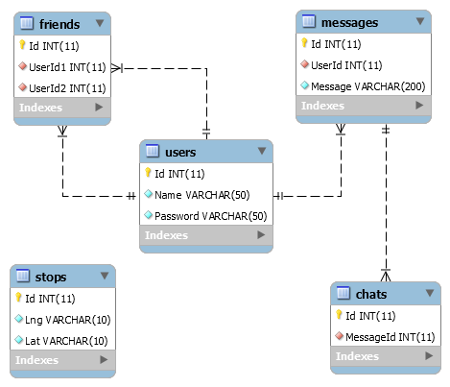

## Screenshots of all the meaningful windows you're planning in your project 3-5 of them:

